Anabela Petrushevikj
MSDA Capstone
March 31, 2026

A.
The research question for this project is: How accurately can a multiple linear regression model predict used vehicle prices based on vehicle characteristics? This question was selected because pricing in the used vehicle market is influenced by multiple factors, including mileage, vehicle age, fuel type, transmission, and condition. These variables interact in ways that are not always easy to evaluate without a structured analytical approach, making data analysis necessary to better understand pricing behavior.
The context of this research is the used car market, where both buyers and sellers rely on accurate pricing to make informed decisions. Without data-driven methods, pricing can be inconsistent, leading to vehicles being either overpriced or undervalued. By applying multiple linear regression, this study aims to quantify how different vehicle characteristics contribute to price and determine whether these relationships can be used to produce reliable predictions. Prior research supports the use of regression models to analyze how variables such as mileage and vehicle age impact used car prices (Zhang et al., 2024).
The hypothesis guiding this study is that a multiple linear regression model can accurately predict used vehicle prices with at least 70% accuracy. The null hypothesis states that such a model cannot be constructed using the dataset. To evaluate this, the model will be assessed using statistical measures such as R² and p-values. If the model achieves an R² value of at least 0.70 and demonstrates statistical significance, the alternative hypothesis will be supported. This approach ensures that both predictive performance and statistical validity are considered when answering the research question.

B.
The data for this project was obtained from a publicly available dataset titled “Used Car Price Prediction Dataset” hosted on Kaggle (Najib, 2024). The dataset includes approximately 4,000 records, with each row representing a used vehicle listing. It contains relevant variables such as brand, model, model year, mileage, fuel type, transmission, accident history, clean title status, engine specifications, and price. These variables were selected because they represent the key characteristics that influence how used vehicles are priced in the market and are necessary for building a predictive regression model.
One advantage of using this data-gathering approach is accessibility. Because the dataset is already compiled and publicly available, it allows for efficient analysis without the need for time-consuming data collection processes such as web scraping or surveys. This makes it possible to focus more on data preparation and model development. However, a disadvantage is that the researcher does not fully control the dataset. Some variables may contain inconsistencies, formatting issues, or missing values, which can impact the quality of the analysis if not addressed properly.
During the data collection process, several challenges were identified, particularly related to data formatting and variable consistency. For example, price and mileage values were stored as text rather than numeric values, and certain categorical variables contained missing or unclear entries. These issues were addressed during preprocessing by converting variables into appropriate formats, handling missing values, and standardizing categories. By cleaning and organizing the dataset before analysis, the data was made suitable for use in a multiple linear regression model and ensured that the results would be reliable and meaningful.

C.
The data extraction and preparation process began by importing the dataset from a CSV file into a Python environment using the Pandas library. Pandas was used to load the dataset and inspect its structure, including column names, data types, and the overall shape of the data. Initial checks were performed to identify duplicate records and missing values. Duplicate rows were removed to ensure that each observation represented a unique vehicle listing, and a summary of missing values was generated to understand the extent of incomplete data.
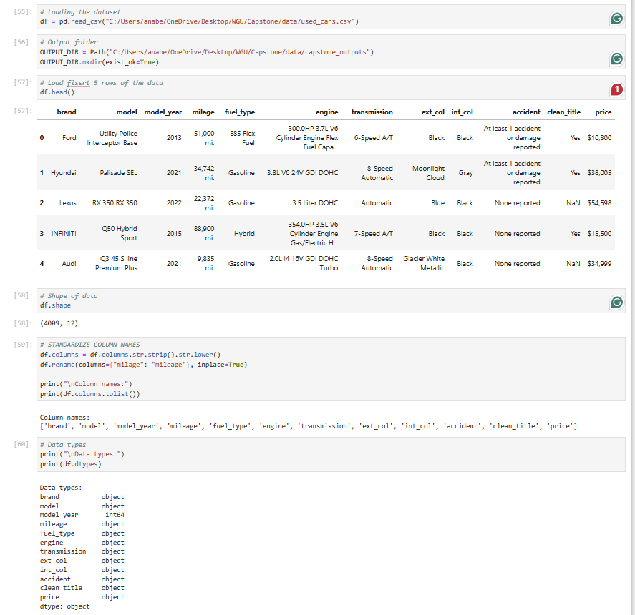
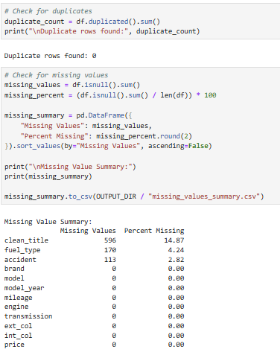
Several data preparation steps were then applied to make the dataset suitable for analysis. First, key variables such as price and mileage were converted from text format into numeric format since they were originally stored with symbols and non-numeric characters. Feature engineering was also performed by creating a new variable, vehicle age, calculated from the model year. Additional variables, such as horsepower and engine size, were extracted from the engine column using pattern matching. Categorical variables, including transmission type and brand, were simplified and grouped to reduce unnecessary complexity and improve model performance. Missing values in categorical fields were handled by assigning a default category, such as “Unknown,” while numerical fields were later addressed using imputation techniques within the modeling pipeline.
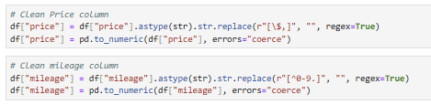
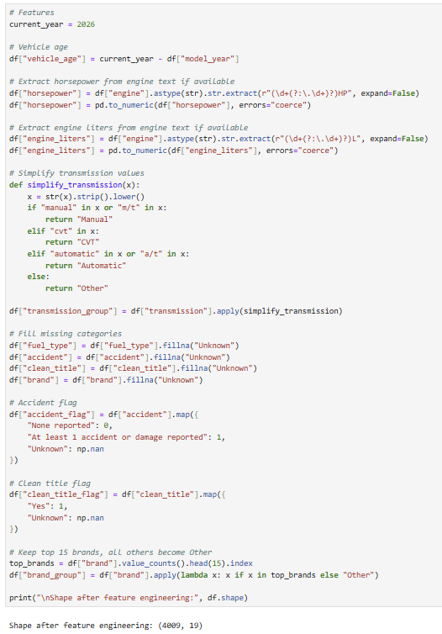
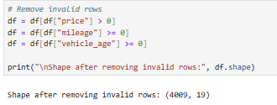
Outliers were identified and removed using the interquartile range (IQR) method to reduce the impact of extreme values on the regression model. This step helped ensure that the model would not be overly influenced by unusually high or low values. A normality test was then conducted on both the original price variable and a log-transformed version of price to evaluate whether the data met regression assumptions. Because the price distribution was skewed, a log transformation was applied to improve normality and stabilize variance.
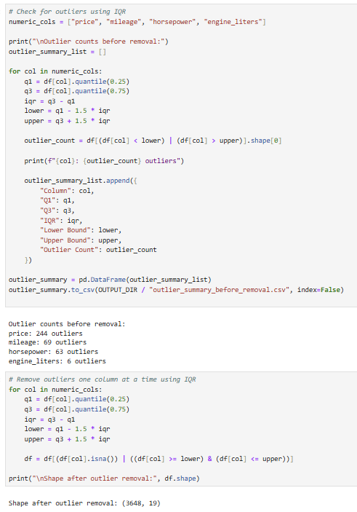
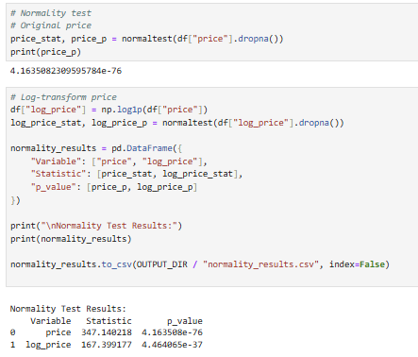
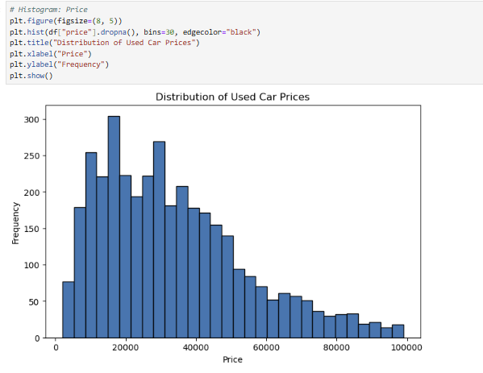
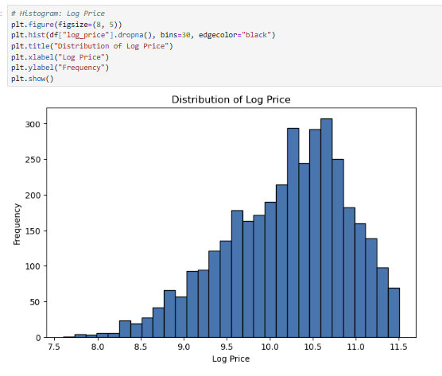
The tools used in this process included Pandas and NumPy for data manipulation, and Scikit-learn for preprocessing and model preparation. These tools were chosen because they provide efficient and reliable methods for handling structured datasets and preparing data for machine learning models. One advantage of using these tools is their flexibility, allowing multiple preprocessing steps to be combined into a single workflow. However, a disadvantage is that they require careful handling to ensure that transformations are applied consistently, especially when working with both training and testing data.

D.
The data analysis for this project was conducted using multiple linear regression to evaluate how vehicle characteristics influence used car prices and to determine whether these variables can be used to accurately predict price. This technique was selected because it allows multiple independent variables, such as mileage, vehicle age, fuel type, and transmission, to be analyzed simultaneously against a continuous dependent variable. Multiple linear regression is widely used in predictive modeling due to its interpretability and ability to quantify the effect of each variable on the outcome (Montgomery et al., 2012).
The analysis began with exploratory data analysis, where visualizations such as histograms and scatter plots were used to understand distributions and relationships between variables. The price variable was found to be right-skewed, so a logarithmic transformation was applied to improve normality. A normality test was conducted before and after transformation to verify that the log-transformed variable better satisfied regression assumptions.
The dataset was then split into training and testing sets using an 80/20 ratio. A multiple linear regression model was trained on the training data and evaluated on the test data. The model produced the following results:
R² on log(price): 0.7537
R² on original price scale: 0.6476
RMSE: 12,567.41
MAE: 8,282.31
These results indicate that the model explains approximately 75.37% of the variance in the log-transformed vehicle prices, exceeding the 70% threshold defined in the alternative hypothesis.
Residual analysis was performed using a normality test to evaluate whether the regression assumptions were satisfied. The residual normality test produced a p-value of 2.64 × 10⁻¹⁴, indicating that the residuals deviate from perfect normality. While this suggests that the model does not fully meet all classical regression assumptions, the large sample size and strong R² value still support the reliability of the model for predictive purposes.
One advantage of multiple linear regression is that it provides interpretable results, allowing for a clear understanding of how each variable contributes to price prediction. This makes it useful for real-world applications such as pricing decisions. However, a limitation is that it assumes linear relationships between variables and can be sensitive to violations of assumptions such as normality and homoscedasticity. Despite this, the technique was appropriate for this study because it effectively captured the relationship between vehicle characteristics and price while achieving the required level of predictive accuracy.
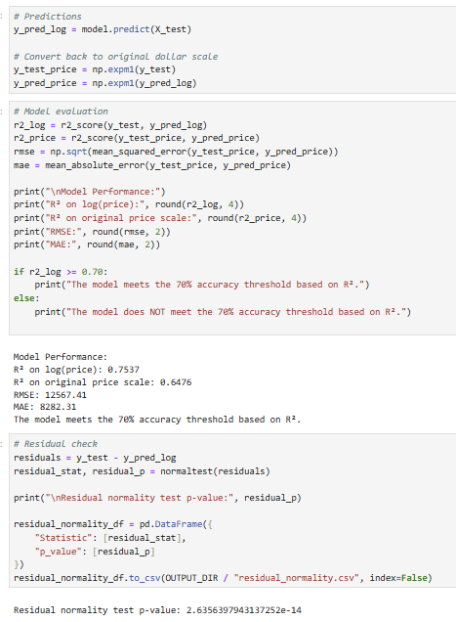
E.
The results of the analysis show that multiple linear regression can be used to effectively predict used vehicle prices based on vehicle characteristics. The model achieved an R² value of 0.7537 on the log-transformed price, indicating that approximately 75% of the variation in vehicle prices can be explained by the selected variables. This directly answers the research question by demonstrating that vehicle attributes such as mileage, age, fuel type, and transmission have a measurable and meaningful impact on price. Because the model exceeded the 70% accuracy threshold, the alternative hypothesis is supported, indicating that a multiple linear regression model can accurately predict used vehicle prices. These findings are consistent with prior research demonstrating the effectiveness of regression models in predicting outcomes when multiple variables are involved (Kutner et al., 2005).
One limitation of this analysis is that the model does not fully satisfy all regression assumptions, particularly normality of residuals, as indicated by the small p-value from the residual normality test. This suggests that there may still be patterns or nonlinear relationships in the data that the linear model does not fully capture. Additionally, some potentially important variables, such as detailed vehicle condition or geographic location, were not included in the dataset, which may limit the overall predictive accuracy.
Based on these results, it is recommended that multiple linear regression be used as a baseline model for estimating used vehicle prices, especially in situations where interpretability and simplicity are important. The model can provide useful insights for dealerships, online marketplaces, and individual sellers by helping them make more informed pricing decisions based on measurable vehicle characteristics.
For future research, one possible direction would be to explore more advanced machine learning models, such as random forest or gradient boosting, to determine whether nonlinear methods can improve prediction accuracy beyond the current model. A second approach would be to incorporate additional data features, such as geographic location, market demand, or detailed vehicle condition, to better capture factors that influence pricing and further improve model performance.
F.
Kotsiantis, S. B., Kanellopoulos, D., & Pintelas, P. E. (2006). Data preprocessing for supervised learning. International Journal of Computer Science, 1(2), 111–117. https://www.researchgate.net/publication/228084519_Data_Preprocessing_for_Supervised_Learning
Kutner, M. H., Nachtsheim, C. J., Neter, J., & Li, W. (2005). Applied linear statistical models (5th ed.). McGraw-Hill. https://www.mheducation.com/highered/product/applied-linear-statistical-models-kutner/M9780073108742.html
Montgomery, D. C., Peck, E. A., & Vining, G. G. (2012). Introduction to linear regression analysis (5th ed.). Wiley. https://onlinelibrary.wiley.com/doi/book/10.1002/9781118535141
Najib, T. (2024). Used Car Price Prediction Dataset. Kaggle. https://www.kaggle.com/datasets/taeefnajib/used-car-price-prediction-dataset
Zhang, Y., Liu, H., & Chen, X. (2024). Research on factors affecting second-hand car market prices. https://www.researchgate.net/publication/382400299_Research_on_factors_affecting_second-hand_car_market_prices

